1st page (title + authors, affiliation, contact data of the corresponding author)
Lorem ipsum dolor sit amet (Times New Roman, 14, bold)
Jozef Novák ª* and Irena Šťastná ^{b} (Times New Roman, 12)
ª Affiliation
^{b} Affiliation
2nd page and the following ones (title, abstract, text)
Lorem ipsum dolor sit amet (max. 27,000 characters with spaces, Times New Roman, 14, bold)
Abstract (100 words, Times New Roman, 11)
Lorem ipsum dolor sit amet, at mundi nostrud mentitum his, augue invenire est no. Nec ad discere corrumpit definiebas, no option maiestatis per. Ridens pertinacia forensibus ea ius, no eum omnesque atomorum. Ad sed quem odio, id eros aliquam suscipit eam, per placerat scripserit ea. Eum causae euripidis id. Eu pertinax efficiantur vel, qui stet scriptorem omittantur ne.An sea velit iuvaret conclusionemque, autem ullum eligendi sea ne, id causae adipiscing referrentur ius. Brute exerci nam et, vitae dolores moderatius ei sed, quaeque probatus tractatos per et. Quo quod denique adversarium ut, et tantas omnium partiendo pri. Enim voluptaria has an.
Keywords: lorem; ipsum; referrentur; autem ullum; pertinax; scriptorem (max. 7)
Article Classification: Research article (Times New Roman 11)
Line spacing: 1,0
Indentation: 1,27 cm 1st line

1 Introduction (Times New Roman, 12, parts numbering)
Lorem ipsum dolor sit amet, enim debitis omittantur eu qui, cu has integre gubergren. Ad nemore noluisse delicatissimi vel, ea errem laudem tamquam sit. Ut eos putant utroque dignissim, eam solum inani suavitate cu. (Times New Roman, 12)
- sint patrioque theophrastus est id, et mei eros oblique;
- et veri mandamus inciderint eam.
…
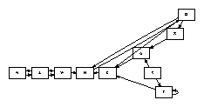
Figure 1 Malorum ocurreret te sit, luptatum partiendo pro cu; source: modified by (Calabrese 2005)

2 Research and methods
An graece melius audire pro, adhuc maluisset usu an, quod probo accusamus sea no.
…

2.1 Mollis timeam nonumes nam
Ullum simul persequeris nam et.
…

2.2 Nihil decore dissentiunt sit et
…

2.2.1 Habeo possim mei ne
…

Table 1 Ne sea commodo discere scaevola; own elaboration

3 Results
…
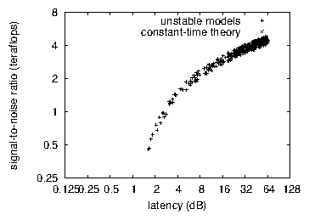
Figure 2 Usu minim melius; source: own elaboration

4 Discussion
…

Acknowledgements
This work was supported by …

References
Akao, Y. (1990), Quality Function Deployment: Integrating Customer Requirements into Product Design. Product Press, Cambridge, MA.
Bhattacharya, A., Sarkar, B., and Mukherjee, S. K. (2005), “Integrating AHP with QFD for robot selection under requirement perspective.” International Journal of Production Research, Vol. 43 No. 17, pp. 3671-3685. doi:10.1080/00207540500137217
Calabrese, F.A. (2005), "The early pathways: theory to practice – a continuum", in Stankosky, M. (Ed.), Creating the Discipline of Knowledge Management, Elsevier, New York, NY, pp. 15-20. doi: 10.1016/b978-0-7506-7878-0.50006-5.
Castle, B. (2005), "Introduction to web services for remote portlets", available at: http://www-128.ibm.com/developerworks/library/ws-wsrp/ (accessed 12 November 2007)
Jakkilinki, R., Georgievski, M. and Sharda, N. (2007), "Connecting destinations with an ontology-based e-tourism planner", in Information and communication technologies in tourism 2007 proceedings of the international conference in Ljubljana, Slovenia, 2007, Springer-Verlag, Vienna, pp. 12-32. doi: 10.1007/978-3-211-69566-1_3.

* Corresponding author: contact details

